## Deploying and Configuring Azure Web Apps

### Lab Overview

In this lab, you will use several Azure Platform as a Service (PaaS) components to configure and deploy an E-Commerce site written using PHP. This web app will use Azure Media Services and Storage as well as MySQL for data.

### Exercise 1: Create the Azure Web App

1. Browse to https://portal.azure.com and authenticate with your Organization or Microsoft Account.

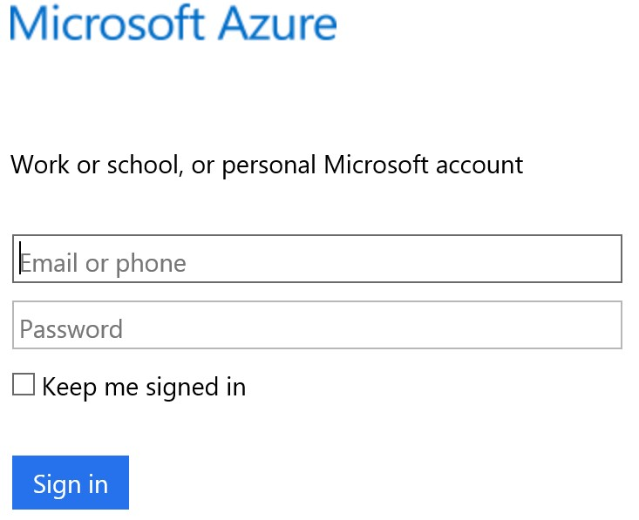

1. Click **New**, and in the search box type: **Web App + MySQL** and press **enter.**

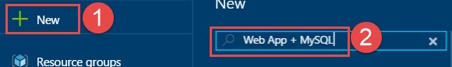

1. Select the **Web App + MySQL** result, and then click **Create** on the next blade.

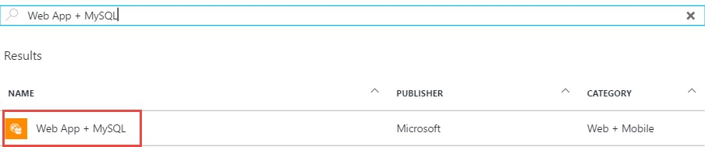

1. Specify the following on the **Web App + MySQL** blade
   * App name: **<unique name>**
   * Resource group: **ContosoDA-RG** • Database Provider: **ClearDB**

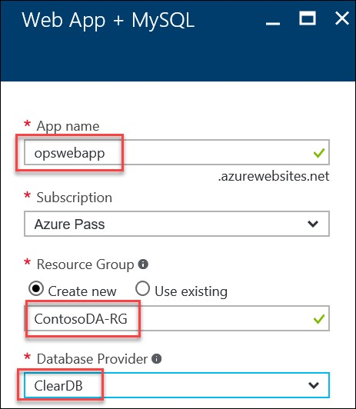

1. Click the **App Service plan/Location** tile.

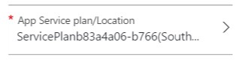

1. Click **Create New**, and specify the App Service Plan as **MyServicePlan**, choose the region closest to you, choose the S1 pricing tier, and then click **OK**.

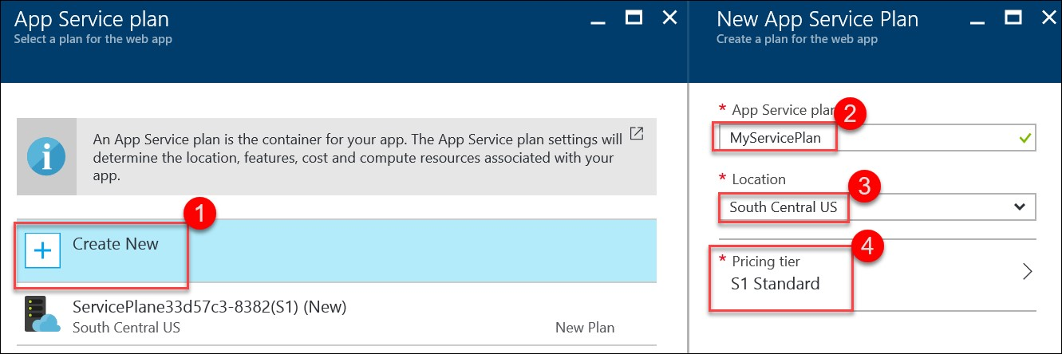

NOTE: If you receive an error that the RG failed to deploy because there is no credit card found associated with the account, choose the FREE option in the Pricing Tier.

1. Click **Database**, and then specify the following and click **OK**.
   * Database Name: **contosodadb**
   * Database Type: **Shared**
   * Location: **<same as your web app>**
   * Pricing Tier: **Mercury**

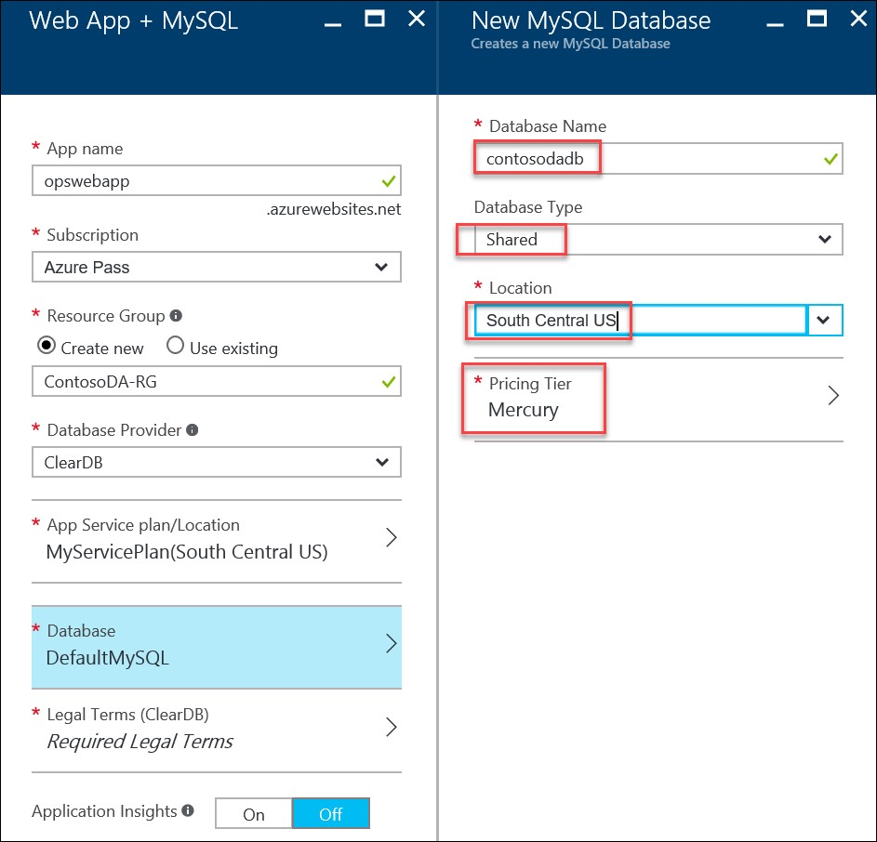

1. Click the **Required Legal Terms** title.

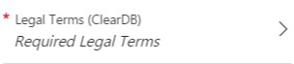

1. Click **Purchase**.



1. Check the **Pin to dashboard** checkbox and click **Create**.

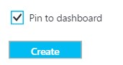

### Exercise 2: Create an Azure Storage Account

1. Click Resource groups on the navigation and then click **ContosoDA-RG**.



1. Click the **Add** button on the toolbar.



1. In the find dialog, enter **Storage Account** and hit Enter on your keyboard.

1. Click the **Storage account** option, then click **Create**.

1. Specify a unique name for the storage account. Ensure the green checkmark is displayed.

Enter/select options to match the following diagram.

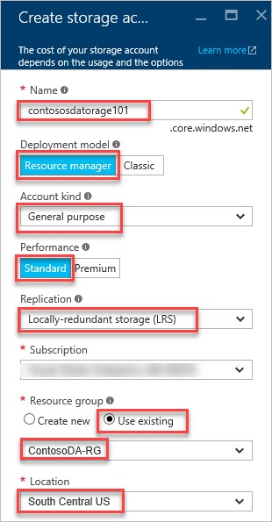

1. Check the check box next to **Pin to dashboard** and click **Create**.

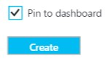

1. After the storage account has provisioned, click **Access keys** under **GENERAL**, and then copy the **Storage account name**, and the value for **key1** to a text editor for temporary storage.

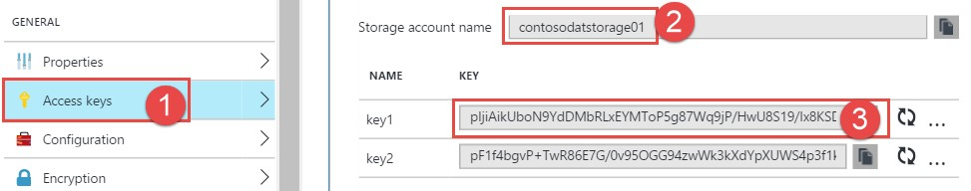

### Exercise 3: Create an Azure Media Service Instance

1. Open your browser and navigate to https://portal.azure.com. Click +**New** > **Web + Mobile**, and then select **Media Services** from the FEATURED APPS list.

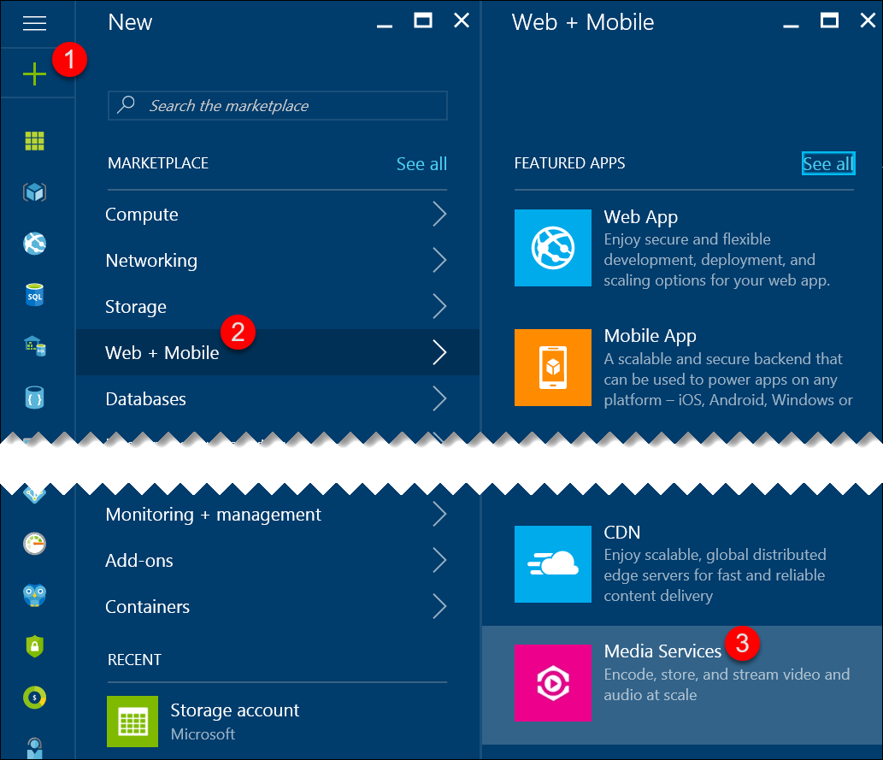

1. Specify the following in the **Media service** blade and click **Create**.
   * Account Name: **<uniquename>**
   * Resource group: **ContosoDA-RG**
   * Location: **<location nearest you>**
   * Storage Account: **contosodastorage101**

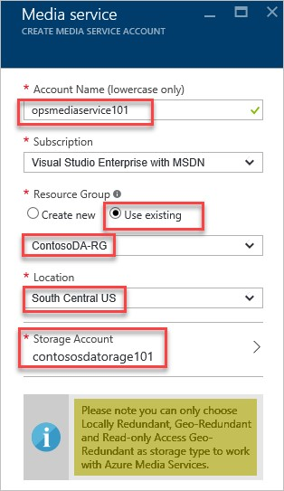

1. After the Media service is created, you need to obtain the **Account Keys** of the service. Click

**Resource groups > ContosoDA-RG > opsmediaservice101**

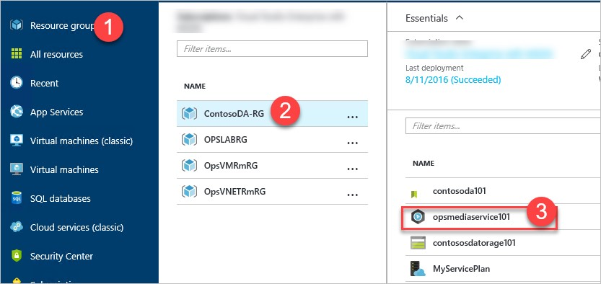

1. Copy the name of the media service account and the access key and save them in a text editor for future reference.

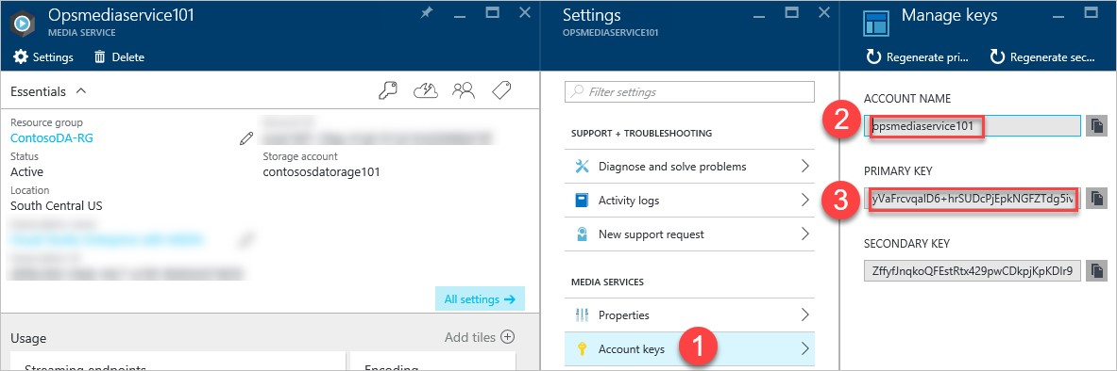

1. Click **Media reserved units** on the Settings blade, change the value to **2** and click **Save**.

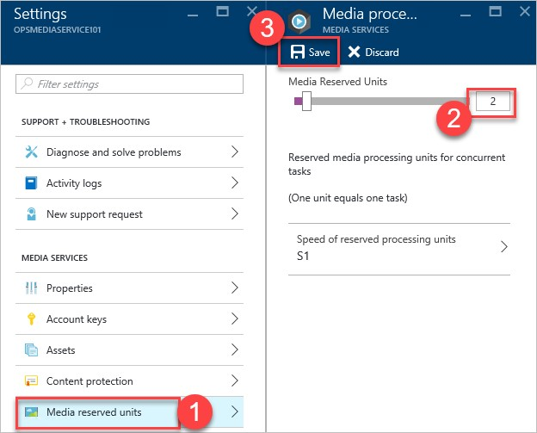

### Exercise 4: Update and Review the Web App Settings

1. In the Azure portal (https://portal.azure.com), click Resource groups on the navigation and then click **ContosoDA-RG**.



1. Click the MySQL database **contosodadb**.

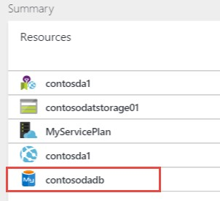

1. Under the **GENERAL** settings, click **Properties**.

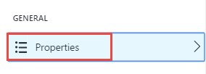

1. Note that this is the connection string to connect to the MySQL database. You can copy the value to the clipboard by clicking the copy icon.

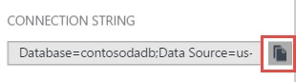

1. Close the MySQL Database configuration blades, and then click the Web App from the **Resources** list of the resources group.

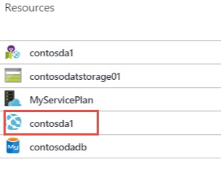

1. Click the **Application Settings** link under **SETTINGS**.

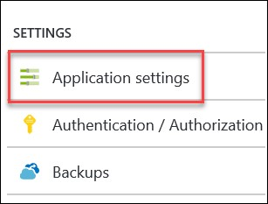

1. The connection string is already set for the web app. This value will be accessible within the application as an injected environment variable.

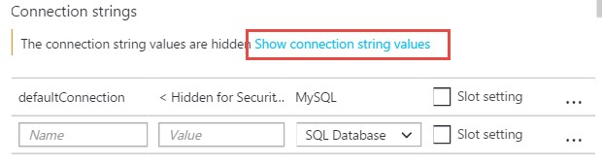

1. Within App settings, add six new entries using the app settings names below along with the storage account name, key, and media services account and key and click **Save**.

|  |  |
| --- | --- |
| STORAGE_ACCOUNT_NAME_WEBSITE | Storage Account Name |
| PRIMARY_ACCESS_KEY_WEBSITE | Storage Account Key |
| STORAGE_ACCOUNT_NAME_WEBJOBS | Storage Account Name |
| PRIMARY_ACCESS_KEY_WEBJOBS | Storage Account Key |
| MEDIA_SVC_ACCOUNT_NAME | Media Service Account |
| MEDIA_SVC_ACCESS_KEY | Media Service Key |

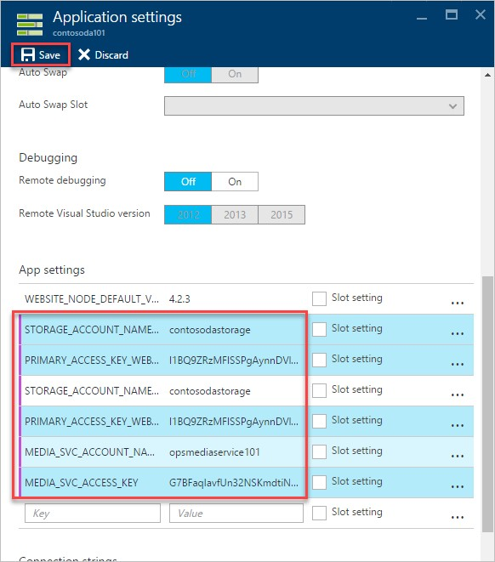

1. On the same blade, change the **PHP version to 5.5**, and click **SAVE** on the toolbar.

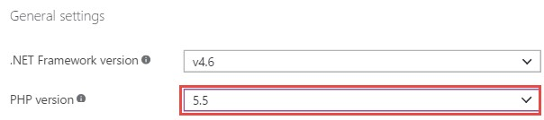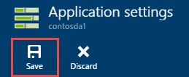

### Exercise 5: Configure Staged Publishing

1. If you do not have an account for GitHub, navigate here: https://github.com/ to create one. If you already have an account login with your GitHub credentials.

1. Navigate to https://github.com/opsgility/php-da-sample and click the Fork button

and specify where (which account) to fork the repository to.



1. After the fork is complete, clone the site locally on your computer for future changes by executing the commands below. Open a command Prompt (Admin) to run the commands.

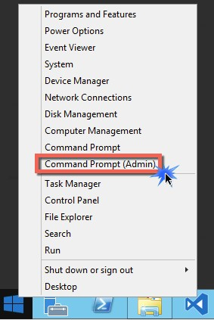

|  |
| --- |
| cd c:\OpsgilityTraining mkdir repos cd repos  git clone https://github.com/[**YOUR_GITHUB**_**USERNAME**]/php-da-sample |

1. In the Azure portal, click **Resource groups > ContosoDA-RG > contosoda101** to open the settings of the App Service

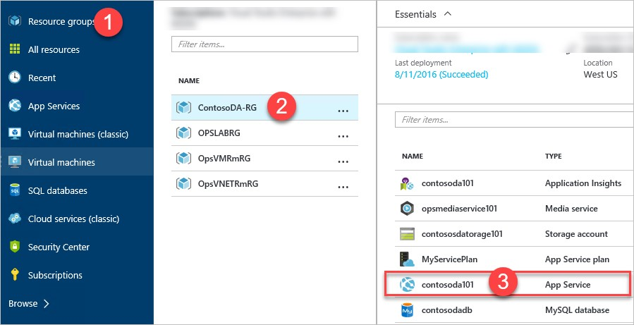

1. Click **Deployment slots** under the **APP DEPLOYMENT** settings category.

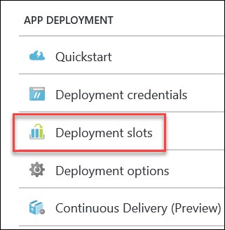

NOTE: If you deployed with the Free plan, you can now choose the S1 Standard plan and it will upgrade to allow for Deployment Slots to be created and utilized.

1. Click **Add Slot**.



1. Name the slot **Staging**, and specify the primary site as the **Configuration Source**, click **OK** to create the deployment slot.

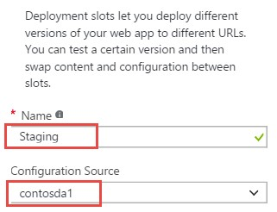

1. Once the staging slot has been created, click its name.

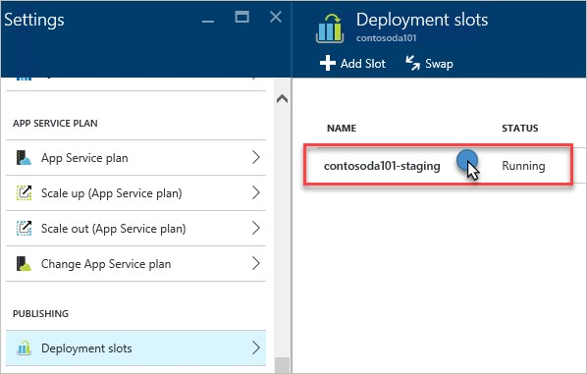

1. Within the Staging slot, click **Deployment options**.

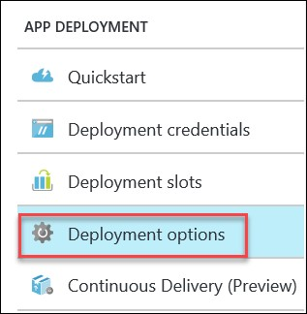

1. Click **Choose Source**

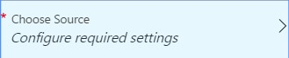

1. Select **GitHub**

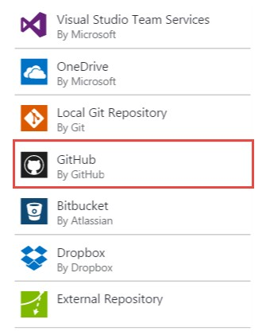

1. Click **Authorization**.On the **Authorization** blade click **Authorize**.

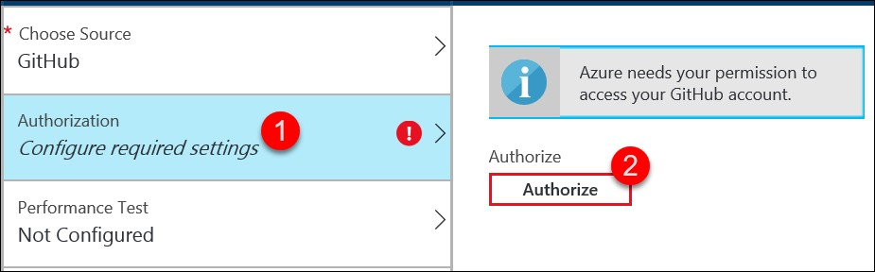

1. You should be prompted to sign into your GitHub account and allow access to your GitHub account. Once complete the **Authorization** tab will indicate the authorization process is complete. Click **OK**.

1. After that is configured, Click **Choose project**.Select the forked **php-da-sample** and click **OK**.

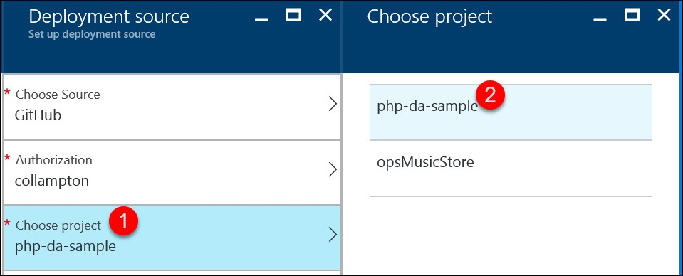

1. Click on **Choose branch**. Click on **master** then click **OK**.

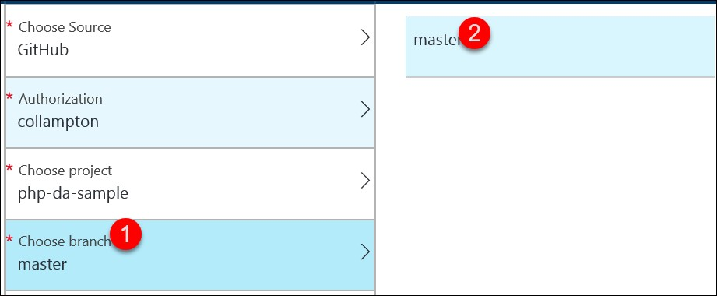

Click back on **Deployment options**.After several moments, you should see the Web App fetching the build from the GitHub repository.

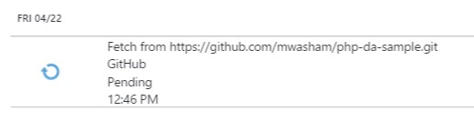

1. After the site has synchronized, click the **Overview** menu for the staging slot, then click on its URL.

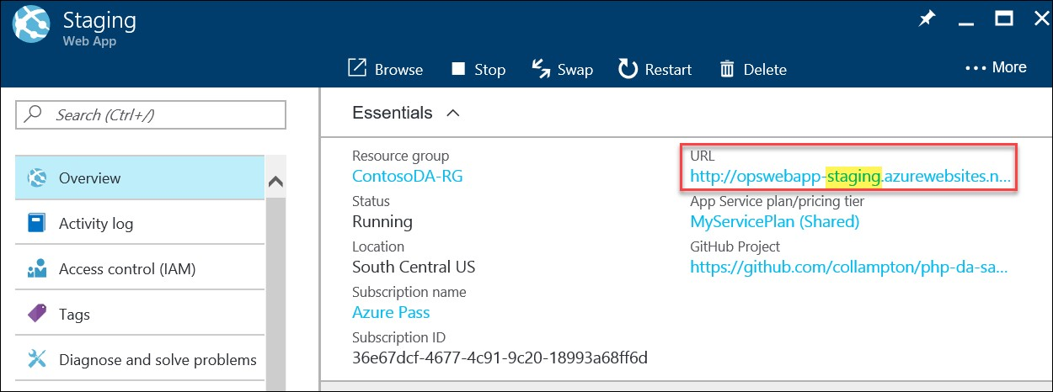

1. It may take several minutes for the site to initialize.

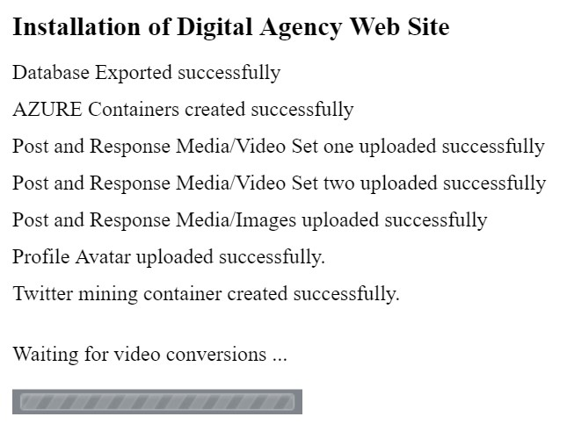

1. Click the **click here** link to continue to the completed site.



1. You should see the home page load.

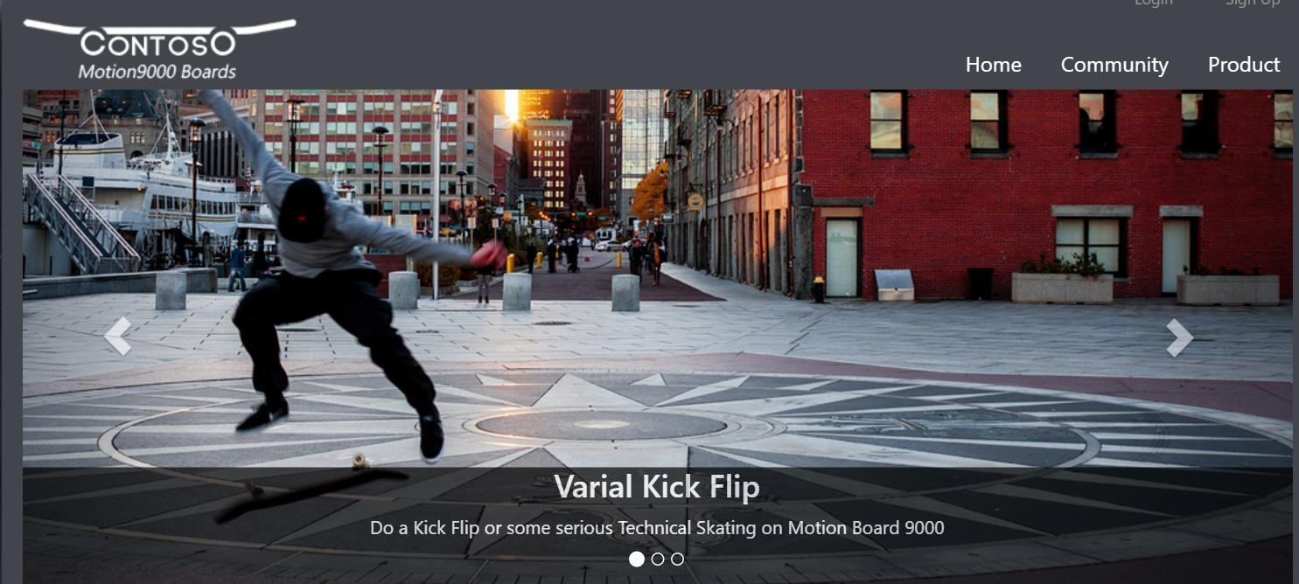

### Exercise 6: Test Swap and Continuous Integration

1. Before swapping the slots, confirm that there is a blank site in production by clicking **Resource groups > ContosoDA-RG > contosoda101** to open the settings of the App Service



1. Browse to the URL specified

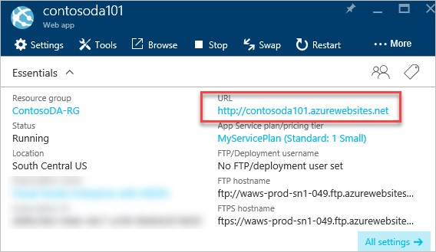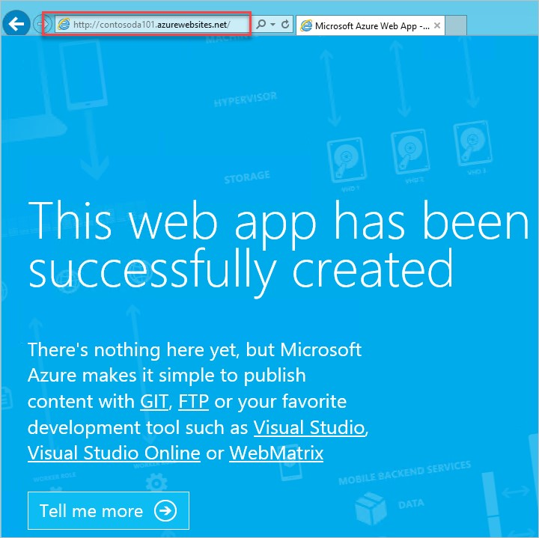

1. Within the Staging slot, click the **Swap** button on the toolbar.

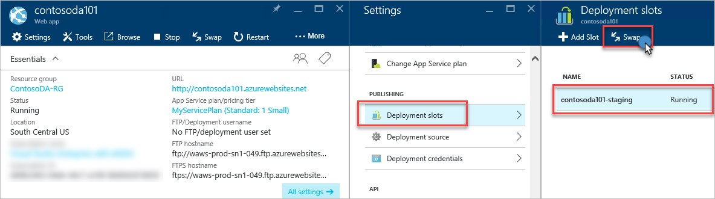

1. Specify **Staging** as **Source** and **production** as **Destination** and click **OK** on the Swap blade.

Note: Swap this is the method to move source from one slot (Staging) to another (production).

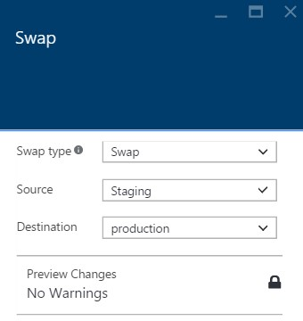

1. You will see the portal update with this message

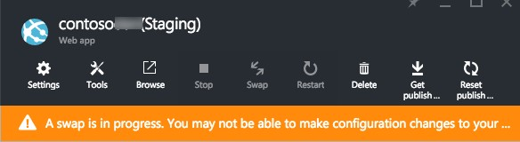

1. After the Swap has completed navigate to both the production web app and the staging. The staging web slot should have the default page:

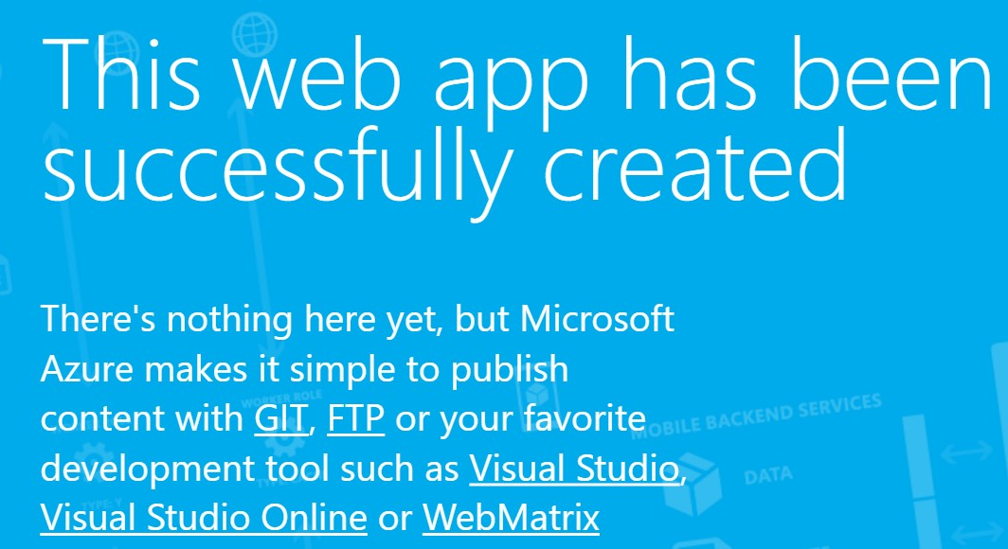

1. Open the following file in Notepad or Visual Studio **C:\OpsgilityTraining\repos\** **php-dasample\application\views\pages\home.php**.

1. Click Ctrl+F and Find the following HTML code.

<h3>Pro Skate Board Motion 10000</h3>

<p> Do all your cool stuff on Contoso board Motion 10000.</p>

1. Make a modification to the text such as changing the model number and then click File→Save.

<h3>Pro Skate Board Motion 20000</h3>

<p> Do all your cool stuff on Contoso board Motion 20000.</p>

1. Move to a **command prompt** and execute the following git commands from the directory where the repo resides to push the update to your repository in GitHub (**c:\OpsgilityTraining\repos\php-da-sample**).

|  |
| --- |
| git config user.name "Your Name" git config user.email "your@email.com" git add -A  git commit -m “updated model” git push |

Note: You will be required to authenticate using your github.com username and password.

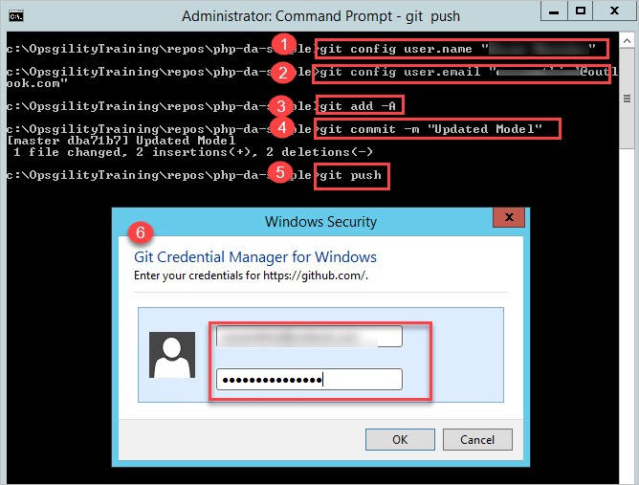

1. Within the Azure Management Portal, click **Resource groups** on the navigation and then click **ContosoDA-RG**.



1. Click the **Staging** slot.

1. Click the **Deployment options** tile.

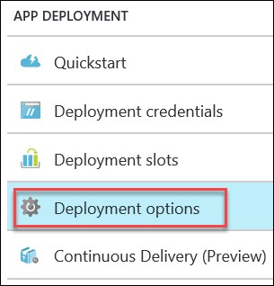

1. You should see the new change being deployed (or completed).

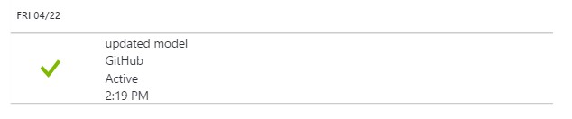

1. Click the URL for the staging site again to see the updated change.

Note: You may have to press CTRL-F5 to refresh the cache.

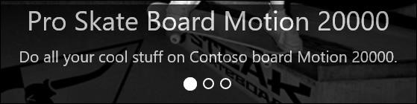

The site could now be swapped to production after validation.

### Lab Summary

In this lab, you used several Azure Platform as a Service (PaaS) components to configure and deploy an E-Commerce site written using PHP.